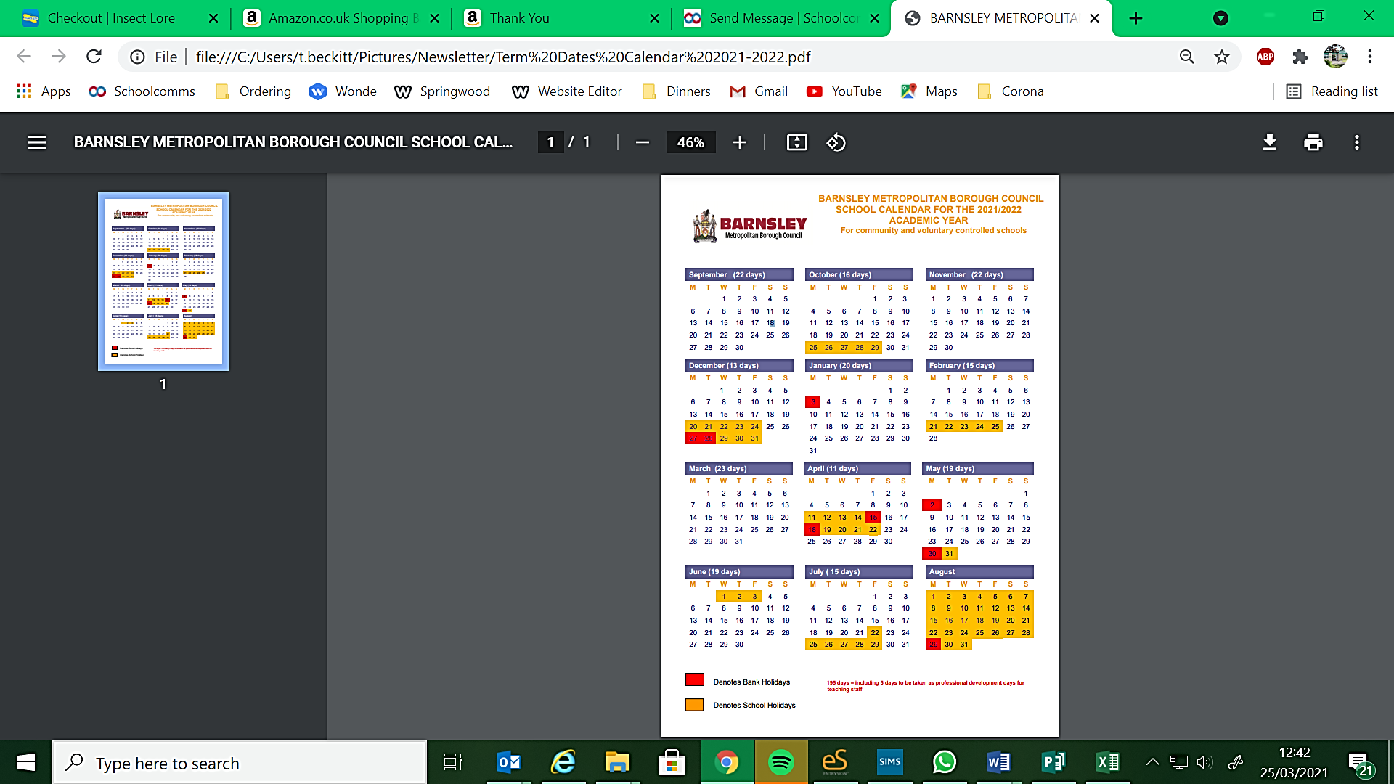

**Hoyland Springwood Primary School INSET Day**