MFL | A |  |  | B
Year 3 | I am Learning Spanish (early) | Phonics 1 & 2  (Extra Teaching) | Ice-cream  (early) | I am Learning Spanish (early) | Animals  (early) | Fruits  (early)
Year 4 |  | My Home  (intermediate) | Vegetables  (early) |  | Presenting Myself  (intermediate) | Seasons  (early)
Year 5 |  | I know how…  (early) | At the café  (intermediate) |  | Phonics 3 & 4  (Extra Teaching) | The Weekend  (progressive)
Year 6 |  | My Family  (intermediate) | The Date  (intermediate) |  | Me in the World  (progressive) | The Weather  (intermediate)

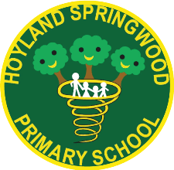
MFL is covered on a two-year cycle which incorporates all 4 key language skills: reading, writing, speaking and listening. These are covered within every unit.
Each full term, one unit of MFL needs to be covered within their Spanish books. At the beginning of each year, all classes will recap, or teach, the ‘I am Learning Spanish’ unit to ensure this basic knowledge of numbers to 10, colours and greetings is consolidated.
The units to be covered span the age ranges of the classes, however, the specific units to be taught will be directed by the MFL lead, based on prior learning of the cohort to ensure no units are repeated.

