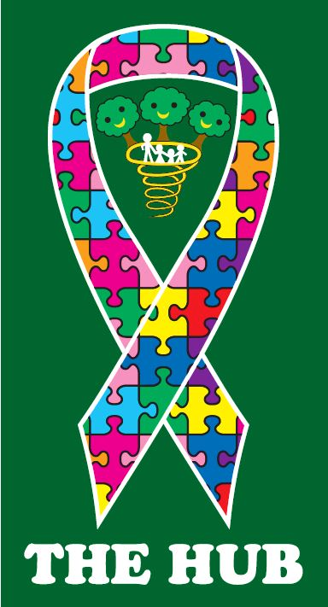
The Hub
2020-2023

“No Boundaries”
Curriculum

Hoyland Springwood The Hub Vision
‘To support all children to embrace all opportunities and rightfully take their place in society. Equipping them with knowledge to shape their own futures and skills to lead an enriched and healthy life with every chance of independence.’ We will provide each child with support, nurture, kindness, independence and new experiences to inspire a bright future.

The Ethos
Holistic approach to education and learning skills to become independent.
Unique pupil support, with a unique curriculum tailored to individual needs.
Broadening horizons for all children regardless of barriers they may face.

The curriculum
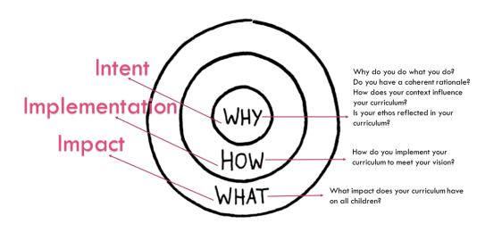
What impact does your curriculum have on all children?
How do you implement your curriculum to meet your vision?
Why do you do what you do?
Do you have a coherent rationale?
How does you context influence your curriculum?
Is you ethos reflected in your curriculum?

Our curriculum Intent
We believe in a broad and balanced ‘No boundaries’ curriculum that grows and develops life long learning, builds interests, is expressive and creative and encourages togetherness in the school and wider community. It is centred around the child’s happiness – the most important aspect of our curriculum. This is built on positive relationships, independence, coping skills and achievement and success.

The Hub curriculum comprises all learning and other experiences that each school plans for its pupils. The national curriculum forms one part of the school curriculum. DFE (2014)

Intent explained – The Hub ‘No Boundaries’ Curriculum
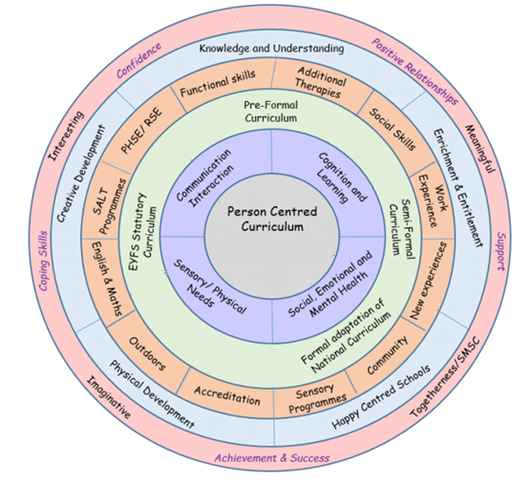
The curriculum model is based on the pupils needs in our provision. It embodies:
• Pupil need at the centre of the curriculum.
• The four key areas of learning underpinning each pupils needs.
• The organisation of the different curriculums suited to need.
• Elements of learning that may be included in each pupil’s personalised curriculum, dependent on interests, strengths, needs and areas of development.
• Core strands of the curriculum that learning are taught for all pupils.
• The “No Boundaries” approach which will aim for pupils to build skills in the 5 key ‘Happy Centred’ areas. These are confidence, positive relationships, achievement and success, support, and coping skills that are taught through interesting, meaningful, imaginative ways that build social, moral, spiritual and cultural skills.

Key Areas for Learning
At the heart of what we do are four core areas of life and learning that are essential for our pupils to develop, in order for them to reach their fullest potential. These key areas are the backbone of our curriculum and are at the core of everything we do. They key areas are as follows:
Sensory/Physical Needs:
• Spatial awareness
• Mobility/moving
• Using hands and feet
• Levels of moving
• Gross motor skills/ body awareness
• Dance and rhythm
• Exercise and food to be healthy
• Swimming: tolerating/enjoying water, strokes, safety, length/distance
• Control of own body and objects

Communication:
• Language/symbols/sign
• Motivation and wanting to communicate
• Expressive/receptive language
• Ways to communicate needs/wants
• Play behaviour and communicating to others
• Conversation skills (intensive interaction to verbal conversation)
• Inclusion
• To use PEC’s system or Makaton purposefully

Social, Emotional and Mental health:
• Self - Care
• Making choices
• Behaviour
• Private/public
• Environment and knowing where you are going
• Moving around inside/outside
• Asking for needs/wants appropriately
• Relationship
• Wellbeing and Coping strategies

Cognition and Learning:
• Understanding and using cause and effect
• Thinking; what will I do next? What do I do first?
• Looking, Listening and Concentrating
• Problem solving and risks for learning
• Creativity
• Ownership/responsibility
• To be able to respond appropriately to changes.
• Curiosity, exploration and questioning
• Generalise and use skills learnt in other places
• Basic English and Maths skills

Curriculum implementation
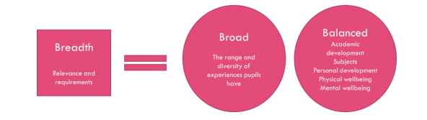
Curriculum content will deliver our curriculum philosophies, purpose, entitlement and development expectations, whilst ensuring opportunity of coverage of the statutory requirements of the national curriculum

Staff use a termly long-term planning format that enables them to shape the curriculum for their learners. They use a breadth of subject content from the national curriculum and tailor this to make it appropriate and meaningful for each child. This ensures that all pupils experience a wide breadth and balance of learning. Long-term outcomes also incorporate EHCP and Pupil Progress Priorities. Curriculums are planned around themes, and celebrations of learning are an expectation.
Low level cognitive demand. Involves following instructions
Higher-level cognitive demand beyond recall. Requires application involving some degree of decision making
Cognitive demand involves non-standard, non-routine, inter –connected, multi-step thinking in problems with more than one possible solution. Requires reasoning and justification

Learning must be engaging for each pupil, without this, pupils will struggle to be interested, and therefore pupil progress and depth of learning will be limited. The ‘No Boundaries’ curriculum, created by Hoyland Springwood, ensures that learning is engaging and will always be appropriate.

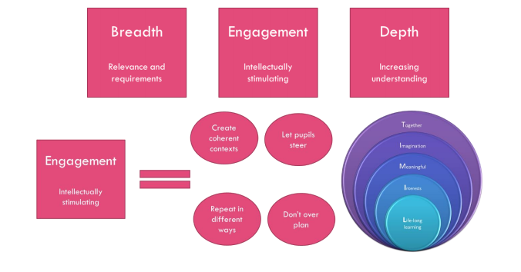

Individualised Curriculum
Teachers plot on a termly tracker for each individual pupil, which learning outcomes and curriculum breadth that pupil has worked on each term. This is underpinned with the use of Evisense which creates an ongoing portfolio. This ensures that learning and skills can be further developed in the future, but also ensures that all pupils have access to a wide range of opportunities and learning.
Even though the majority of our pupils are accessing a pre-formal and semi-formal curriculum, we still feel it is important to utilise the National Curriculum requirements, so that we have high expectations of giving our pupils new experiences and skills across a breadth of different areas. This enables us to make an informed decision about what each pupil is interested in, their strengths and how we can support them to develop further.
All pupils will work on these skills throughout their day, some of our learners who are focusing on a pre-formal (P1-P4) curriculum, will solely focus on these four areas. The curriculum is split further into six strands for our pupils who are following a semi-formal curriculum. A proportion of our pupils will follow a more formal adaptation of the national curriculum (P8 and beyond), broken down into fourteen strands.
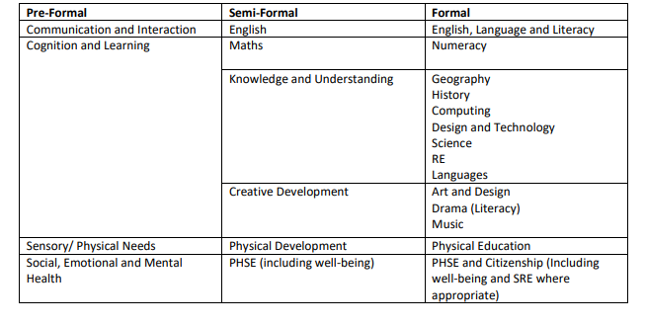
Each Pupil has an Education Health Care Plan focusing on the four key areas of the curriculum. In turn, these targets put in place the foundations for pupils achieving their long-term goals into adult life.

The Role of the Teacher
• To plan and teach the four key areas through the statutory EYFS curriculum, pre-formal curriculum, semi-formal curriculum, a formal adaptation of the national curriculum.
• To plan focussed opportunities for teaching and learning of the four key areas, through a rich array of experiences, using the ‘No Boundaries’ approach to planning.
• Include elements of learning that are personalised to meet the needs of each individual learner.
• Use themes and projects to enhance and enrich pupils learning of the four key areas.
• Plan pupil led activities to increase interest and motivation.
• Ensure that depth and breadth of the curriculum are planned for through engaging activities.
• Allow the pupils time and opportunities to practise and generalise their learning across other areas.
• Give pupils space and opportunities to self-discover learning.
• Ensure the learning environment meets the expectations of the school policy, reflects the needs of learners, and supports their outcomes.

Methods and Ideas
By consistently using the ‘No Boundaries’ approach to teaching and learning, it ensures that teaching focuses on developing life long skills, it is interesting, imaginative and meaningful and is taught in ways to promote togetherness.
To create an inclusive approach we ensure the curriculum:
• Uses the long-term planning formats customised for our pupils.
• Is pupil centred, needs led and individualised.
• Is responsive and flexible to individuals needs and interests.
• Uses expertise beyond the classroom – at home, in the community and local environments.
• Incorporates cross-curricular links and is exciting, interactive and engaging for all.
• Develops the pupil as a whole – their knowledge, skills and emotional health and well-being.
• Is broad, balanced and demonstrates progress in knowledge and skills.
• Prepares the pupil for now and for later life by considering the big picture – life skills, social skills, communication and independence.

Curriculum Impact
We triangulate evidence and data from a number of sources, throughout the school year, to gauge the impact of our curriculum. These include:
- Drop-in programmes linked to personalised teacher’s standards developed specifically for Coppice Teacher profiles
- Peer-to-Peer observations
- Planning Critiques Work/ Evidence scrutinies
- Pupil Progress Meetings Progress pupils have made towards individual targets and EHCP targets Team/ Individual Action Plans and progress made towards these Environment walks and critique Learning walks
- Pupil Voice Carefully selected Continual Professional Development programmes in line with the School Development Priorities and the impact this has on teaching and learning.
- Regular reviews and critiques of the curriculum and its development

