Ancient Greece
Y3 | Y4 | Y5 | Y6
Big Question  Bronze Age Greece (2000-1100BC) | Big Question  The Archaic Age (850-600BC) | Big Question  Power struggles -who will win? (classical age – 500-400BC) | Big Question  Art and culture (classical age 500-400BC)
The location of Greece meant flow of people and trade to Europe, north Africa and middle east.  1  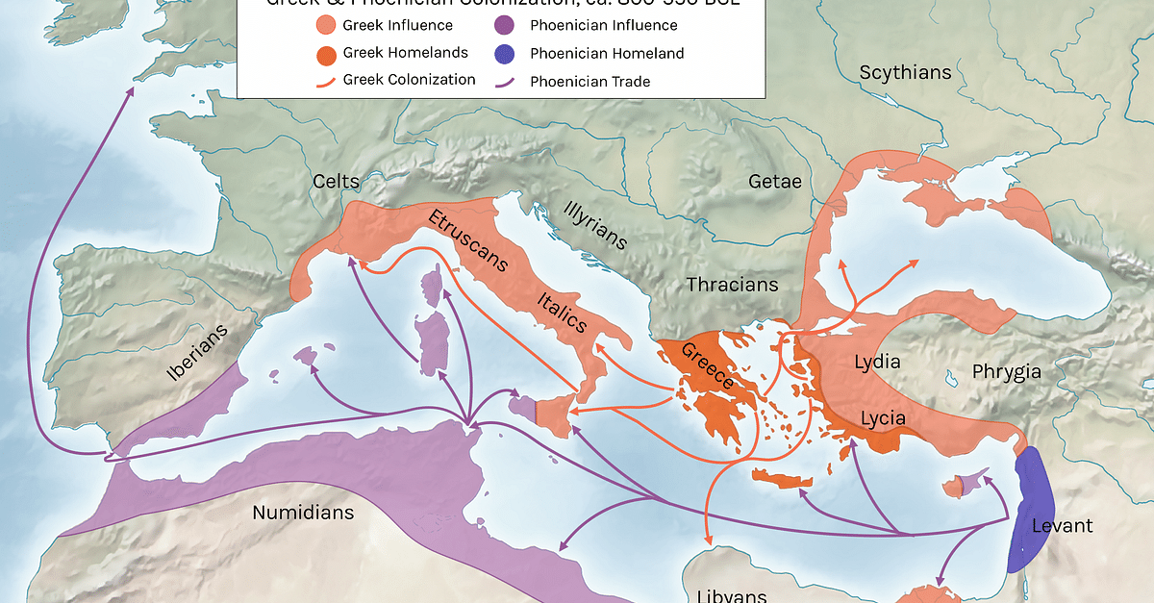  - trade mainly by sea routes through Aegean sea | City states – capital and territory – quarrelled between themselves and competed.  1  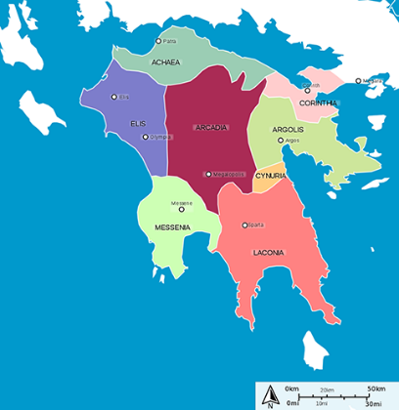  - There were numerous city-states within Ancient Greece.  - The most powerful or influential city-states were Athens, Sparta, Thebes, Corinth, and Delphi.  - The people of each city-state did not refer to themselves as Greeks- refer to themselves as an Athenian, Spartan, or Corinthian.  - Corinth famous for trade and architecture.  - Sparta was known for its military.  - They also fought against each other such as in the war between Athens and Sparta. Would sometimes work together against a common enemy. | Main power was with Athens and Sparta  - Sparta ruled by two kings  - Spartan army was fierce and protective  - Athens ruled by archons who were elected annually  - Athens the birthplace of democracy invented in about 507BC  - Athens had a powerful navy | Art and culture:  Theatre  - Tragedy and comedy words come from Greece  - Performed in outdoor theatres – began as open areas in cities or hillsides, by 6th century BC, theatre structures were being built. Theatres got larger and larger, holding as many as 15000 people.  - Parts of the theatre - orchestra, theatron, skene, parados  Poetry  1  - Epic poems – long poems that don’t rhyme and describe a serious topic  - Homeric epics described deeds of the warriors of Greece who led the war against Troy  - Homer – (historians don’t know if he was a person) wrote The Iliad and The Odyssey  - Hesiod – 700BC wrote Works and Days which is about farming  - Archilochus – 650BC wrote more personal stories  - Sappho – first woman poet -short love poems  Sculpture  - Use people in artwork as they were very important part of life  - Sculptures of gods and goddesses in human form could be worshipped at festivals  - Sculptures of gods would be bigger and more detailed than those of regular humans  - Archaic period – stone, outside  - Classical period – more natural and real looking, started being put in buildings  - Hellenistic period – wealthy could buy sculptures.  - Use bronze and marble  Temples  2  - Purpose – store a religious statue  - Varying sizes  - The Parthenon – temple in Athens, honour the goddess Athena, made of marble, 46 doric columns
Landscape meant a lot of sea travel due to mountains and rocky interior – lead to many sea-based stories.  2  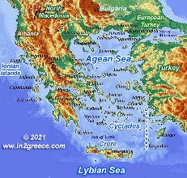  - Hard to cross land  - Many ports built for trade  - Good mariners  - Poseidon – one of the 3 most powerful Greek gods, rules the sea and water, important to sailors and fishermen, carries a trident  - Went with brothers Zeus and Hades to battle the Titans  - Overthrew the Titans and took control of the world.  - Divided the world up – Poseidon-sea, Zeus-sky, Hades-underworld | Colonisation  2  - The Greeks set up colonies throughout the Mediterranean and the Black Sea.  - This included settlements in modern-day Italy, France, Spain, Turkey, and parts of North Africa.  - These colonies helped to spread the Greek culture throughout the region. | Persian invasions:  1  Battle of Marathon (490BC) – Persian invasion by Darius.  - Sept 490BC on the plain of Marathon  - Attempt by Persia under Darius I to conquer Greece  - Invading because of Ionian revolt.  - Landed at Marathon Bay and went to the plain of Marathon (field) – flat so good for battle  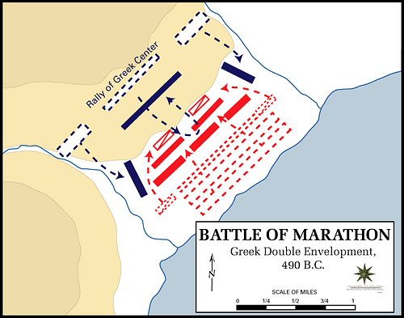  - Athenians marched to Marathon and blocked the two exits of the plain for 5 days  - Many more Persians than Athenians  - Athenians attacked by going round the edges of the Persian army
Study some of the stories of Minoan Crete –  3  King Minos, Theseus and the Minotaur,  - Minos lived on the island Crete  - Minos had a pet monster called a minotaur  - Sent his navy to Athens to attack now and again  - King of Athens offered King Minos a deal  - Not attack for 9 years if he sent 7 boys and 7 girls to Crete to feed the monster  - Minos agreed and did not attack  - Prince Theseus went as one of the boys- he wanted to kill the minotaur  - Ariadne (Minos’ daughter) fell in love with Theseus and gave him some string and a sword  - Killed the minotaur  Icarus  - Daedalus (Icarus’ father) made some wings out of feathers and wax  - Icarus was held captive by king Minos on Crete  - Ignored his father’s warning and flew too close to the sun  - Wings melted and he fell into the sea where he died | 776 – first Olympic games-  3  Why was it started?  - Part of a religious festival to honour Zeus  - God of the sky and leader of Greek Gods who lived on Mount Olympus  What events did they do?  - a cook named Coroebus won the only event—a 192-meter foot race called the stade (the origin of the modern “stadium”)—to become the first Olympic champion  What was it like?  - Held in religious sanctuary of Olympia near the southwest coast  - Only men who could speak Greek took part  - No medals – just one winner who got a wreath of sacred olive leaves  - Heroes welcome back home  - competed for the glory of their city states  - truce was sent out before the games  - sacrifice was the main event at the Olympics – 100 oxen were sacrificed and burnt on an altar to Zeus.  - compare to modern day Olympics | Battle of Thermopylae  - 480BC – second Persian invasion of Greece  - Alliance of Greek city states led by Sparta  - Attacked by Xerxes I of the Perisan Empire because they were defeated in prior invasion  - Took 7 days – 3 in battle  - Greeks blocked the only road the Persians could use- a pass a Thermoplyae.  - Someone betrayed the greeks and told the Persians of a small path they could use.  - Large amount of Greek army was sent to them but the rest were then defeated, leaving the road free for the Persians to come through.  - Greeks were defeated.
Volcano - Thera (Santorini)  4  - Island of Thera devastated by volcanic eruption  - Destroyed settlement of Akrotiri  - Erupted in about 1500BC  - Entirely buried the island under thick layers of ash and pumice  - Ash and pumice from the eruption have been found as far away as Egypt and Israel  - Might have been the source of the stories of Atlantis |  | Battle of Salamis – attack Athens.  - Naval battle between Greek city states and Persia  - Sept 480BC between mainland and Salamis Island  - Athenian General persuaded Greeks to battle Persian fleet again  - Perisan navy blocked the entrances  - Very cramped conditions as so many boats it was hard to move about.  - Greek fleet formed in line and were victorious – sinking or capturing at least 200 persian ships. | Philosophy and thinking:  3  Look at the work of many famous Greeks of the time:  - Socrates  - Plato  - Aristotle  - Pythagoras  - Zeno  - Epicurus  - What did they discover? How are their findings still used today? Do you think they would change their thinking from knowing more recent discoveries in science and technology?
Homer’s Iliad – major Greek poet  Achilles  - Mum wanted to protect him from harm.  - Dipped him in the river Styx which was said to have special powers.  - She held him by the heel.  - Half-god/half-human (not immortal)- very strong – warrior  Trojan War –  - Wife of Greek King Menelaus, Helen, was taken captive by Trojan Prince Paris  - Achilles joined battle to get her back  - War went on for years  - Achilles stopped fighting and Greeks started to lose.  - Patroclus pretended to be Achilles and the Greek army started fighting harder.  - Patroclus died and Achilles went back to battle  - Greek God Apollo knew of Achilles weakness so directed an arrow at his heel.  - Achilles died.  Trojan Horse- 10-year siege on Troy  - High walls around the city  - Sent arrows from the walls  - Tried to get through for 10 years  - Odysseus thought of a trick – built a huge wooden horse and left it outside the gates and then pretend to leave on their boats  - 30 men hiding inside  - People of Troy celebrated and took horse into city  - When asleep, greeks climbed out and opened gates to let army in.  - Beat Trojan army.  - Schliemann’s discovery of site of Troy in 1870 – not necessarily the actual site. | Iliad written by Homer to tell stories from past.  Famous Greek Poet – see Year 3 | Athens and Sparta rivalry:  Compare society in the two – democratic gov in Athens;  2  - For almost 100 years, Athens was ruled by the people with a new government called democracy  - Father of Democracy – Cleisthenes  - People directly in charge of new laws, taxes, public projects and government officials.  - Took place at the Assembly – held on the slope of hills  - Any Athenian person could speak about a law  - There had to be at least 6000 people present to vote at an Assembly  - Only men over 18 years could vote  - Women, slaves and outsiders could not vote  - Theatres were an important part of everyday life  - Boys were better educated than any other city state  military state with monarchy in Sparta.  - Warrior society and had a dominant army  3  - Boys were taught to read and write but mainly the art of war and how to dominate on the battlefield  - Entered military school (Agoge) at 7 years old  - They were beaten daily, given little food and made to fight each other  - Entered the army at 20 years old  - Girls also entered school at 7 years of age- taught how to be strong with exercise and athletic sports  - Married by 18 years old  - Spartan women enjoyed many more freedoms that other city states – own businesses, land, could travel outside the house without permission of father or husband | Hippocrates  - Greek doctor – first person to write that people got sick for scientific reasons rather than gods being angry with them  - Patient confidentiality  - Medical ethics – cannot do anything to kill a patient  - Hippocratic Oath – named after him
Odysseus  - Character in the poem Odyssey, written by Homer  - Trying to get home after the Trojan war  - Wanders for 10 years  - On a boat with 12 others  - Land on an island where everything is much bigger than them – find an empty cave and feast on a lamb  - Shepherd is a giant Cyclops called Polyphemus who is the son of Poseidon  - Grabs two men and eats them  - Plan to kill him when he is asleep  - Rock blocking doorway is far too big to move  - Plan to blind the cyclops and then escape tied to the underside of a sheep | Greek alphabet created  4  - First appeared in records during 8th century BC  - The word ‘alphabet’ is derived from the first two letters of the Greek alphabet - ‘alpha’ and ‘beta’.  - Other alphabets exist because of the Greek alphabet.  - First alphabet to use vowels.  - Didn’t have lower and uppercase letters, this was developed later on.  - The alphabet contains twenty-four different letters.  - Represented letters and numbers  - Basis of many other alphabets | Peloponnesian War (431BC- 404BC) war between Sparta and Athens. Athens surrendered  4  - After Persian war, Athens and Sparta agreed to a 30 year peace  - Athens became powerful and wealthy, expanding its empire, and Sparta got jealous  - Sparta and Athens ended up on different sides in a conflict over Corinth. Sparta declared war on Athens  - First war lasted 10 years – Sparta dominated land, Athens dominated sea  - Athens built long walls so it could access the sea and trade.  - Lots still died inside the city due to the plague  - 421BC – agreed a truce – Peace of Nicias  - 415BC Athens helped an ally on Siciliy. They lost the battle and Sparta attacked starting the second war  - Spartans gather allies, even the Persians  - Athens recovered and won a series of battles between 410 and 406BC  - 405BC Athenian fleet defeated in battle – Athenians began to starve.  - Not enough army to defeat Sparta on land – in 404BC surrendered  - Corinth and Thebes wanted to destroy the city and enslave the people but Sparta disagreed. Athenians were made to tear down their walls but the city was not destroyed or people enslaved. | Archimedes  4  - Inventions allow people to haul heavy goods  - Archimedes screw for lifting water  - Odometer  - Cart with wheels and gears  - Compound pulley  - Catapults and cranes  - Large crater on the moon is named after him.
Dorian invasion led to turmoil  5  - From northern and north western Greece  - At end of Bronze age (1100BC), travelled south to Aegean sea area- maybe for fertile land  - Not as cultured as southern Greeks  - Developed iron swords to slash compared to southern villagers stone weapons  - Conquered Minoan and Mycenaean civilisations.  - Their rule plunged the area into a dark age – they had no written language and did not like art or music | Science – 585BC Thales possibly predicted eclipse of the sun  5  - battle stopped due to light vanishing  - saw it as an omen and settled terms of peace  - did not know that it was the moon coming between the earth and sun  - not clear evidence how he predicted it or whether it was luck (or whether he did it at all!) | Conquered by Alexander the Great  5  - Son of Philip II who was king of a Greece city state in the north of Greece  - Philip united a number of city states and was called Macedonia.  - In 336BC, at 19 years old, Alexander became king and conquered the rest of Greece – he believed he was the son of Zeus and so thought he was immortal | Pythagoras  5  - Theory of right-angled triangles  - a²+ b² = c²  Plato  - One of worlds greatest thinkers  - Set up the Academy in Athens were he taught philosophy, law, reasoning, maths and science  - Earliest ancestor of modern university

Y3 | Y4 | Y5 | Y6
Romans
Big Question  Who were the important people in Roman Britain? | Big Question  Can we see any evidence of the Romans in Britain still around today? | Big Question  How did the Romans control the people? | Big Question  Did the people welcome the Romans or not?
Julius Caesar invasions 55 and 54 BC  1  - 55Bc – two legions attacked. Battled celtic tribes on the southern coast  - Not prepared for the British weather  - Storms and high seas of English channel battered his ships  - Had to anchor big heavy ships in deep water  - Soldiers had to jump into cold water and wade to shore  - Roman army was not powerful enough – went back to Rome.  - 54BC – 5 legions and 2000 cavalry  2  - British tribes agreed to pay tributes to Rome so were left in peace | Roads  1  - Wanted to build an interconnecting set of roads so every part of the empire was connected to Rome  - Britain – Celtic tribes – didn’t have much of a road system  - Important to be able to move armies and equipment easily  - Built roads so soldiers could march by shortest safest route  - Dig a trench – layer big stones then pebbles and sand, then cement and broken stones, put neat cut paving stones on the surface  - Slope down from the middle to ditches on either side – rain drain away  - Long and straight  - Still see some of these roads today – built so well  - Modern roads in same places as many roman roads | Government:  1  - At the beginning of Roman rule – it was a monarchy.  - Around 509BC, the citizens of Rome gained control and established a Roman Republic (the country becomes ‘public’ and is no longer ruled by one person. Officials are elected and share leadership)  - Democratic system  - Two of the magistrates, called consuls, had the most power and had authority over law, religion, military and administration.  - Senate- started as advisors to the consuls but gained power over the years. Initially, only elite roman families could be elected but eventually common people could be elected.  - Assemblies – a group of people who represented each section of Rome. | Focus on peoples’ opinions about each event or area.  Julius Caesar invasions 55 and 54 BC  1  - 55BC He wasn’t prepared for the British weather.  - He was born near the Mediterranean Sea, which is mostly calm and only has a small change in tides.  - English Channel -the storms and high tides battered his ships.  - Caesar’s ships were big and heavy.  - They had to anchor in deep water away from the shoreline. Soldiers had to wade in the cold water in full armour then fight when they reached the land.  - Caesar won some battles and took some hostages. But when autumn brought the stormy weather again, Caesar took his soldiers back to Gaul (an area where countries like France, Belgium and the Netherlands are today). He planned to return the next year to conquer Britain.  - 54BC - Second invasion in the spring- landed without opposition, marched inland and set up a fort  - Had a few battles and set up treaties with some kings but then left because of political developments in Rome.
Claudius invade 43AD  - Roman emperor Claudius – creation of a new warship  - 20000 soldiers landed on south coast  - Attacked celtic tribes and took control  - Made deals to keep the peace – obey roman laws and pay taxes so they could keep their kingdoms  - 11 British kings surrendered and another king, Caratacus, was defeated. | Everyday life – food, mosaics, art, entertainment  Food  - Snails, dormice, peacock – delicacies  - Olive oil, barley and wine – Mediterranean triad  - Introduced proper vegetables to Britain – garlic, onions, leaks, cabbages, peas, celery, turnips and asparagus  - Introduced herbs – rosemary, thyme, bay, basil  - Introduced new farming practices and more productive grains  - Introduced some fruit – apples, grapes, mulberries and cherries  - Introduced animals – pheasants, rabbits and chickens as farm animals  - Hunted wild boar and oxen  Mosaics  2  - Tiny coloured stones called tesserae  - Show scenes of history and everyday life  - Mosaic floors showed how wealthy you were  - Copied from the Greeks  - Cut the stones to make them the right size  - Used natural stones so they are not bright colours.  Art  - Painted pictures directly onto the walls of wealthier roman houses.  - Make rooms seem larger and more open.  - Everyday life or special occasions  - Wanted art to be useful and tell about life in the past or historical events  Entertainment  - Spa or roman baths – not just places to wash – meeting places  - Were equivalent of ‘keep fit centres’ before cleansing the skin  - Dinner parties – eat and meet with important people, included musical performances, acrobatics, dancing, mime, gladiatorial fights and trained animals | Hadrian’s Wall:  2  - 122 AD Built a wall to protect roman England from attacks from the Pict tribes in Scotland  - Coast to coast - took 14 years to build  - Allowed control over people coming and leaving Britain.  - Every mile there was a milecastle (fortified gateway) where soldiers patrolled.  - Two turrets were in between each of the milecastles  - 16 forts were also built along the wall to house the soldiers  - 73 miles long, 8-10 feet wide and 15 feet high | 43AD Claudius – elephants  - His strong and large army quickly conquered the South East of Britain and eleven local tribes surrendered to him. The Roman Army got the ball rolling by defeating the Catuvellauni, who was the dominant tribe in the South East.  - They then successfully invaded Camulodunum, the enemy capital. However, it took many decades until all of England was under Roman rule as the tribes kept on fighting.  - Claudius was better prepared than Julius Caesar before him. He assembled a massive army of 40,000 men with War Elephants & War Machines.  - Claudius stayed in Britain for a grand total of 16 days before returning to Rome. His work was done, he had, through his military victory, made it clear he was a competent Emperor. So, Claudius left but the Roman army was here to stay. They conquered the majority of England and Wales and didn't leave until 410AD
Boudicca (AD 60/61)  3  - Wife of ruler of Iceni Tribe (East Anglia)  - When her husband died, the agreement between him and Romans was destroyed.  - Boudicca led an attack against the roman rulers  - Destroyed Colchester  - Went on to destroy London and St Albans  - Boudicca was defeated. |  | Taxes:  3  - Boudicca was queen of the inceni tribe  - The romans tried to increase taxes and would not let Boudicca be queen.  - Romans stole, made people slaves and had Boudicca whipped  - She did not think this was right and so gathered soldiers to attack the Roman towns of Colchester, London and St.Albans.  - Eventually the Romans won because they were well trained, even though they didn’t have as many soldiers. | Roads and settlements- place names, maps  2  - When the Romans arrived in Britain, they got to work straight away building roads and forts so they could transport soldiers around the country.  - Roads were very straight so that routes were quicker  - They were built on a slant so that rain drained off so that it didn’t get muddy.
Roman Baths
- Places to bathe and socialise
- Used oil then scraped it off with a metal scraper.
- People would meet to talk and have meals
- Fees to get in were fairly small so even the poor could go.
- The floors of the baths were heated by hot air

Hadrian –  4  - Roman emperor from 117 to 138AD  - Built wall- marked north limit of roman territory in Britain  - Near the border of modern day Scotland  - About 73 miles long  - Built the Parthenon and temple of Venus in Rome | Language  3  - Latin was spoken by romans  - Britons spoke Britonic  Latin words we still use today:  - Aqua – water  - Primary – primus ; first  - Musica – music  - Canine – canis;dog  - Librarium- library | Laws:  4  - Laws were made in the assemblies  - The laws were enforced by an official called the praetor and a police force called the Vigiles.  - The Roman constitution was an agreed set of principles but was not written down.  - The law of the twelve tables was written in 450BC  - Only Roman citizens had protection and rights  - The punishments you received for crimes depended on your status  - One of the worst punishments for crimes was crucifixion (link to Easter)  - Many concepts of the roman laws make up the foundations of our systems today. | Attack on Druid stronghold on Anglesey 60AD  - Druids, warriors and women on the opposing side were a very unfamiliar sight to the Romans invading.  - Tacitus (a roman historian) said the scene ‘scared the soldiers into paralysis’  - They set fire to buildings and ‘covered their altars with the blood of captives’  - Troops left to help fight against Boudicca’s armies attack on London.
Taxes –
- The Inceni tribe had a deal with the Romans to rule their kingdom under their terms.
- Boudicca was left part of her husbands’ kingdom when he died. The Romans did not honour his will and took away land, increased taxes and would not let her be queen.
- 60AD they, together with some other tribes, launched an attack on Colchester when the Roman governor was away and moved on to London and St Albans.
- The governor sent troops to fight and they won the battle even though they had fewer soldiers due to their training.
- Boudicca poisoned herself rather than be captured.
 | Christianity  4  - First 300 years that romans ruled Britain – worshipped many different gods  - Christianity started in the middle east by Jesus 25AD  - Very unpopular religion with roman government  - Banned Christianity  - Legend says – Christianity brought to Britain by Jesus’s grand uncle in AD 63 – probably made up  - Traders brought Christian ideas to Britain 2nd century  - Christians were sometimes hunted down and executed in Rome – eaten by lions  - St Alban, St Aaron and St Julius – Christians executed on Britain  - Emperor Constantine changed the law AD 313 saying it was ok to be Christian  - Christianity became very popular |  | Government  34  - Democratic system – common people have a say in what happens through power to elect people to represent them.  - At the top of the Roman Republic was the consul. The consul was a very powerful position. In order to keep the consul from becoming a king or dictator, there were always two consuls elected and they only served for one year. Also, the consuls could veto each other if they didn't agree on something. The consuls had a wide range of powers; they decided when to go to war, how much taxes to collect, and what the laws were  - Senate- started as advisors to the consuls but gained power over the years. Initially, only elite roman families could be elected but eventually common people could be elected. The consuls usually did what the Senate recommended. Senators were selected for life.  - Plebeian Council - The Plebeian Council was also called the People’s Assembly. This was how the common people, plebeians, could elect their own leaders, magistrates, pass laws, and hold court.  - Tribunes - Tribunes were the representatives of the Plebeian Council. They could veto laws made by the Senate..
Entertainments – gladiators, arts etc
4
- Rulers knew that food and entertainments were the things that made common people happy and so great importance was given to games and theatre.
- Games similar to multi-sports took place over several days.
- There were annual festivals
- People liked shows with speed, strength and elements of danger – they liked blood and carnage
- Gladiators fought as entertainment.
- Gladiators were often slaves or criminals who were trained at gladiator schools.
- Fought until death or defeat against criminals or wild animals.
- Chariot racing was a very popular sport all over the roman empire
- Theatres were in every roman city
Military power
- Roman soldiers were very well trained and powerful.
- When they attacked new lands, they were often successful and took over leadership of the area.
- Roman armies were very well trained and organised. They were hard to beat, which helped the Roman Empire expand so quickly and conquer more lands.
- Roman soldiers had to be at least 20 years old when they joined the army, and they had to stay in the army for 25 years. After that, they were rewarded well with some money or land that they could farm.

